Burndown chart

Estimated time

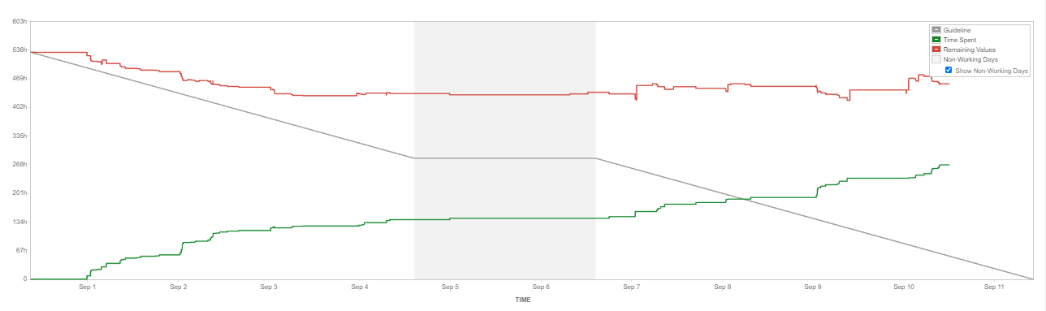

The burndown is a chart that shows how quickly you and your team are burning through your customer's [user stories](http://www.agilenutshell.com/user_stories). It shows the total effort against the amount of work we deliver each iteration. Something like this:

monitoring the project scope creep

Keeping the team running on schedule

Comparing the planned work against the team progression

1. Actual and Estimated work
2. Track sprint progress
3. Identify problem
4. Past and present performance
5. Likely hood of achieving sprint goal

Story Point

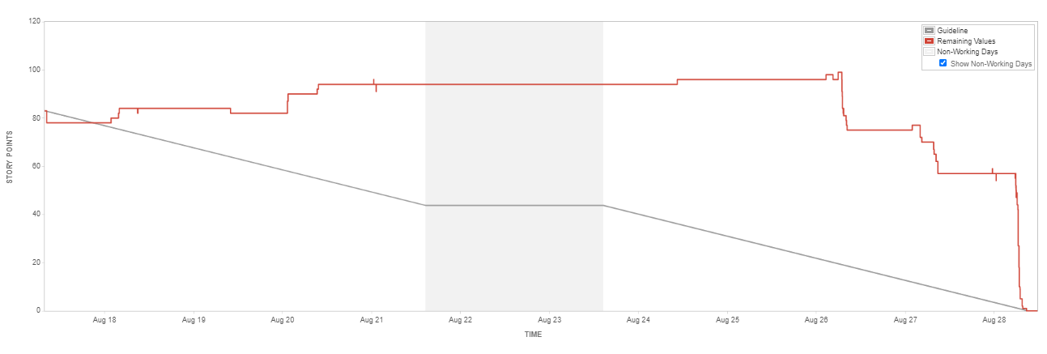

Sprint Report

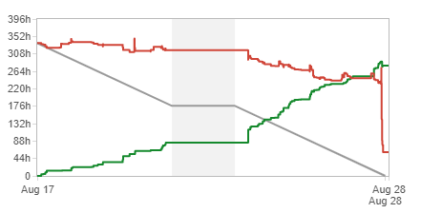

1. List of complete and incomplete issues
2. Summary of sprint progress
3. Useful for sprint retrospective meeting
4. Only applies to scrum board

Velocity Chart

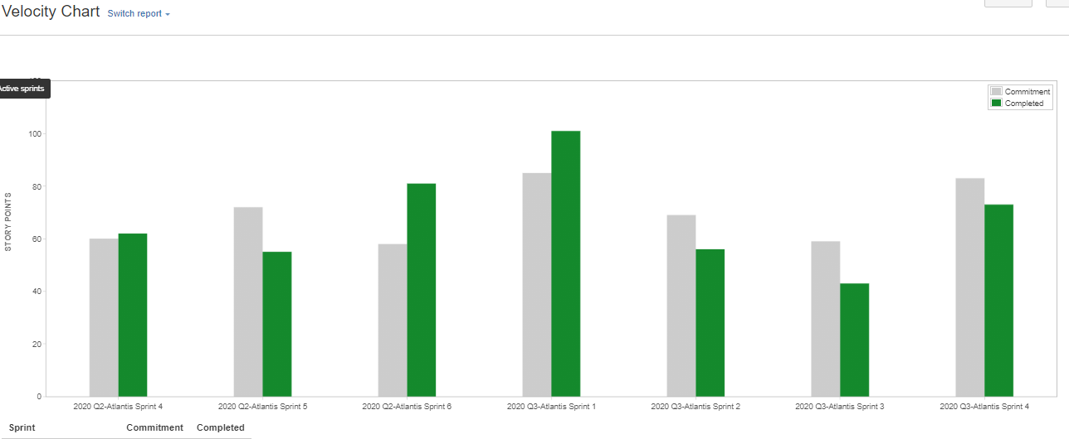

1. Show estimates versus actual work completed
2. Helps predicted future performances
3. Identify trends in commitment and delivery
4. Useful of sprint planning to determine scope.

7 recently complete sprint

Total estimate work

Total completed work

Control Chart

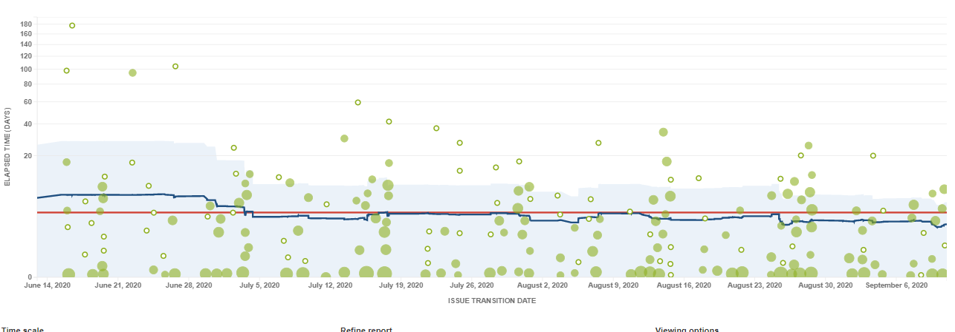

1. Shows cycle time or product version and sprint
2. Maps time spent on issues over specified time
3. Easily see bottlenecks and slowdown
4. Identify workflow design problem
5. More predictable estimation

Epic report

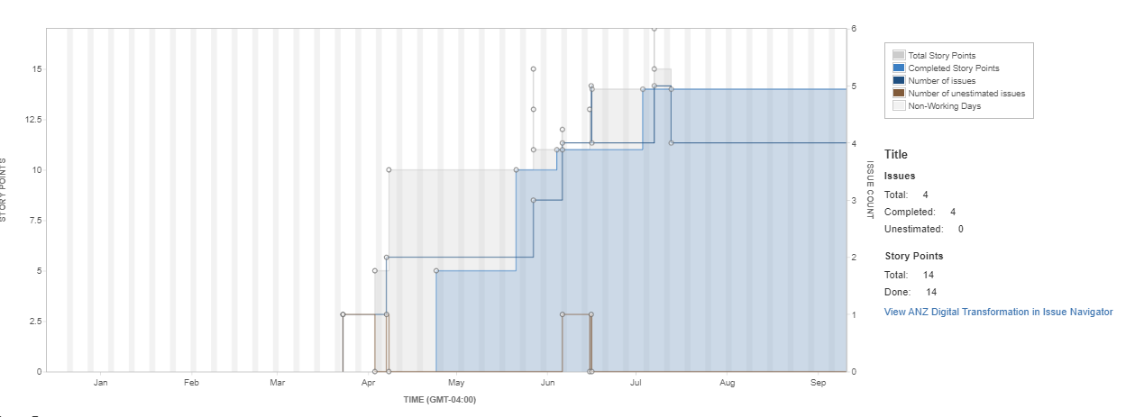

1. Complete, incomplete and non-estimated issues
2. Shows trending progress
3. Tracks remaining works
4. Use full for planning epics spanning multiple sprints
5. Only applies to scrum board